**Adding an aggregation**

**Overview**

In the exercise *Creating an aggregation*, you were asked to create and manage an aggregation in Power Query editor to reduce the data size of the **Fact** table and optimize query performance.

Your tasks in the exercise include:

* Create an aggregation based on the Fact table (**Sales** table) according to the required granularity.
* Configuring the data types of the aggregated columns and the source columns.
* Manage the aggregation in Power BI desktop.

This reading provides you with a step-by-step guide for completing these tasks. It also includes screenshots that you can compare against your work.

You can also review the [*Creating an aggregation*](https://www.coursera.org/learn/data-modeling-in-power-bi/lecture/6BHay/creating-an-aggregation)and [*Managing* *aggregations*](https://www.coursera.org/learn/data-modeling-in-power-bi/supplement/bZTJ6/managing-aggregations)videos.

**Step 1: Download the Adventure Works Power BI project.**

1. Download and save the file **Adventure Works.pbix***.* Load the data from the workbook into Power BI. Select the **Preview** pane to open a table preview. The data model has three tables of data: **Sales**, **Products**, and **Date.**

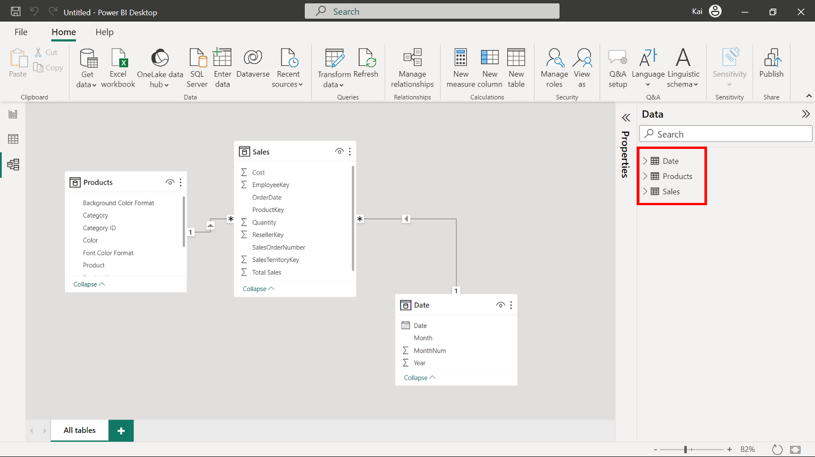

1. Download and save the Excel spreadsheet **Adventure Works Data.xlsx**.
2. Next, select on **File** in the top-left corner of the screen. In the dropdown menu, hover over **Options and settings**, and then select **Data source settings**.

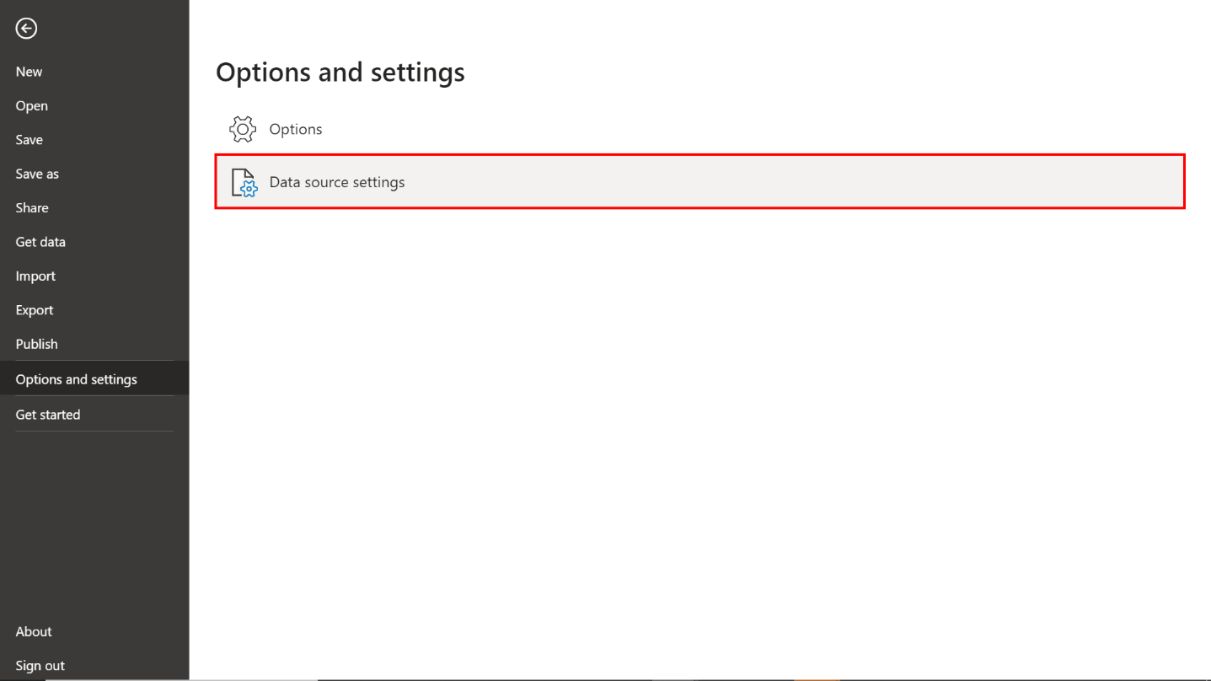

1. A new window titled **Data source settings** will appear. Here, you'll see a list of all the data sources currently used in your Power BI reports.
2. After selecting the data source, click on **Change Source...** to modify its details. Navigate to the file location of the **Adventure Works Data** spreadsheet.

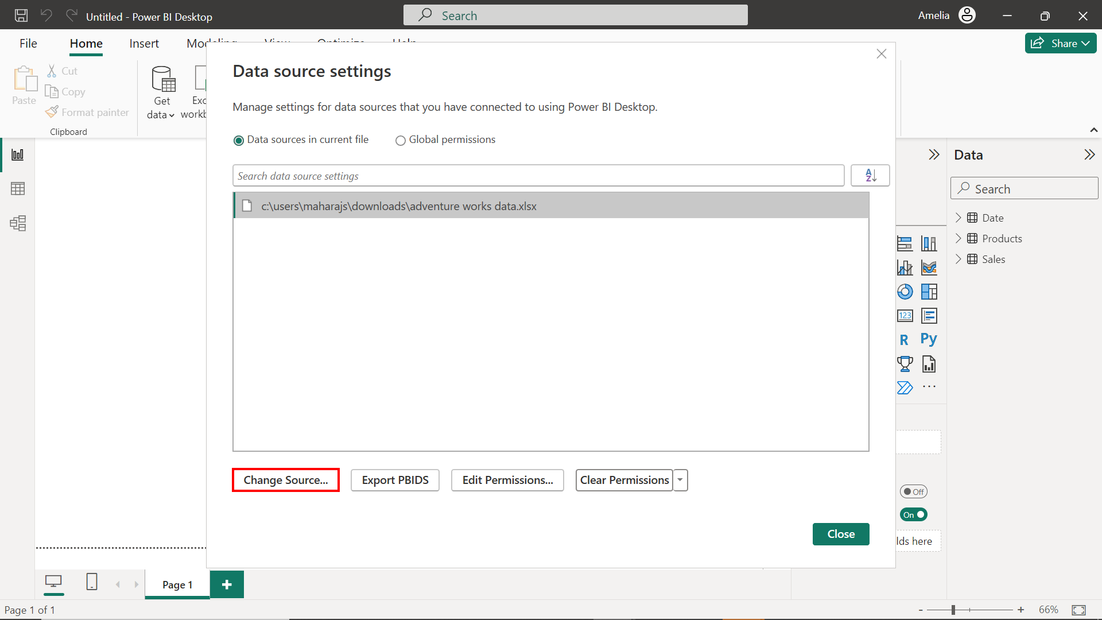

1. Once you’ve made the necessary changes, select **OK** to confirm and Power BI will validate the new connection.

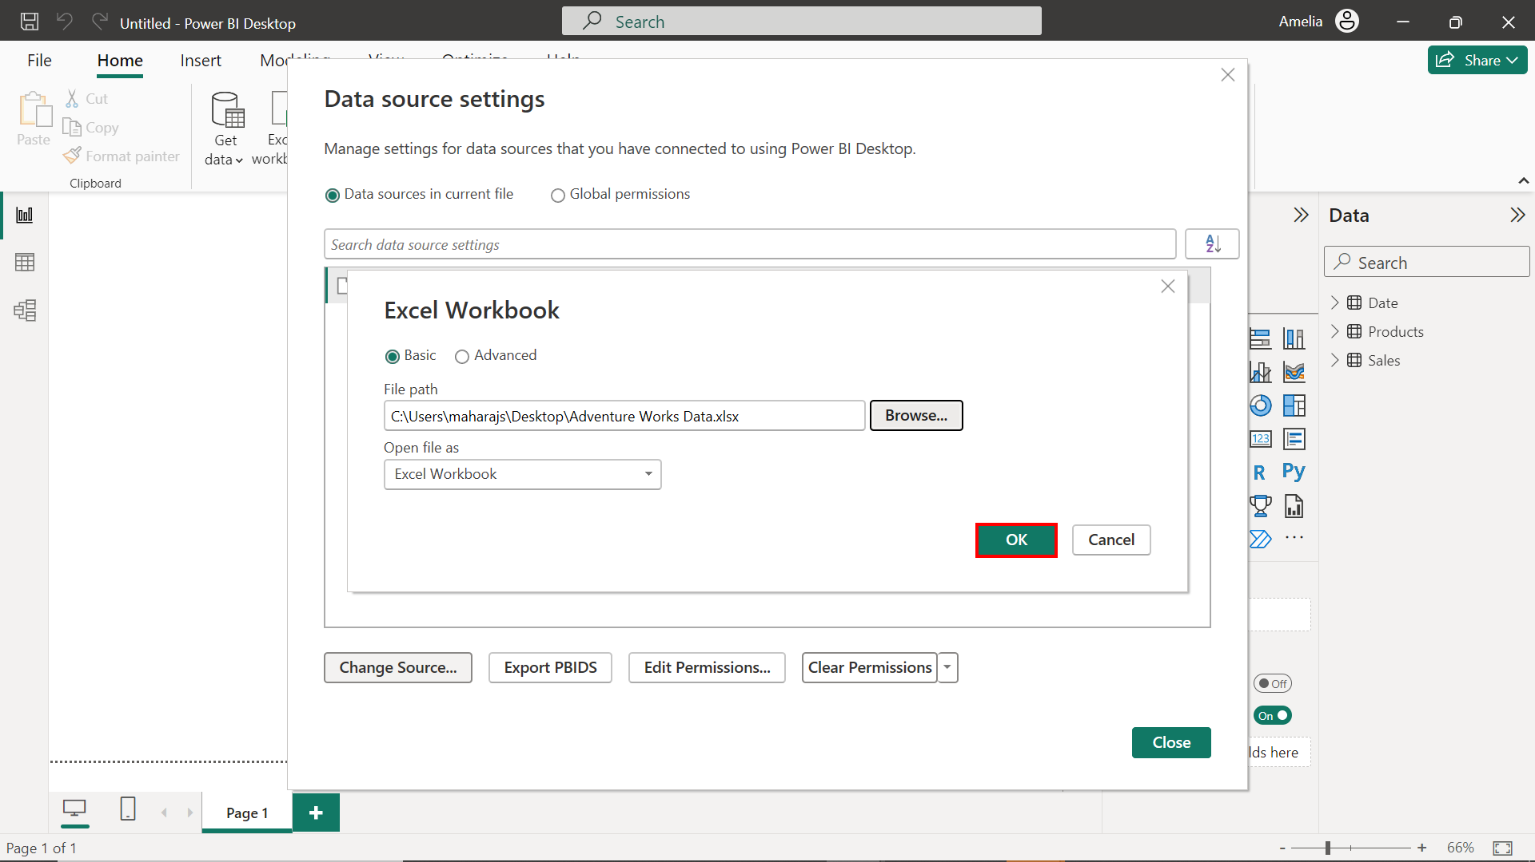

**Step 2: Create an aggregated table named SalesAgg**

1. On the **Home** tab, select**Transform data** and then **Transform data** from the drop-down menu.

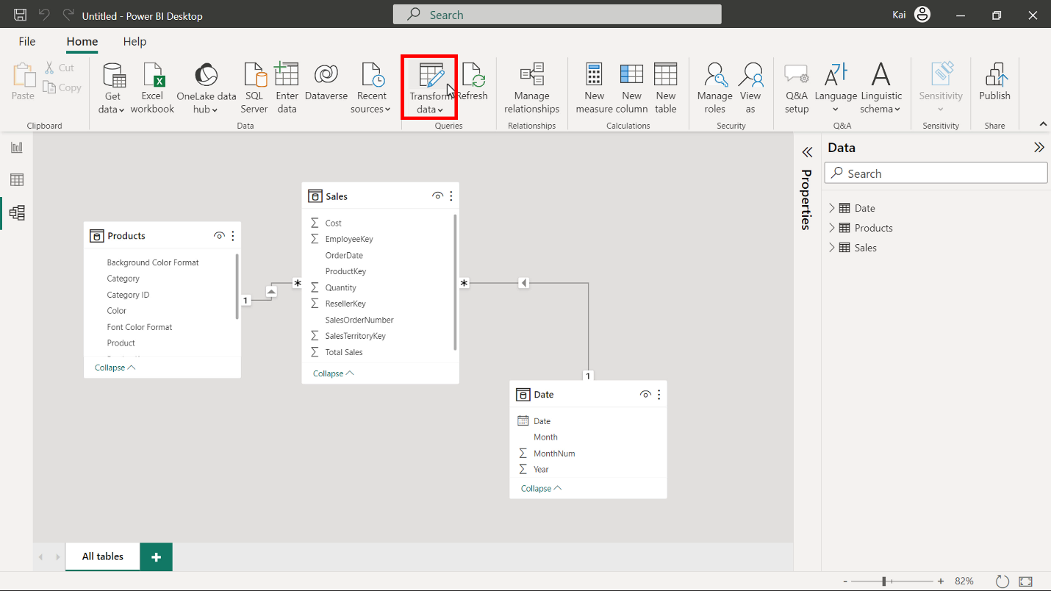

1. In the **Power Query** editor window, select the **Sales** table from the **Queries** pane on the left and right-click to open the context menu. Select **Reference** to duplicate the table. Use right-click again to re-open the menu.

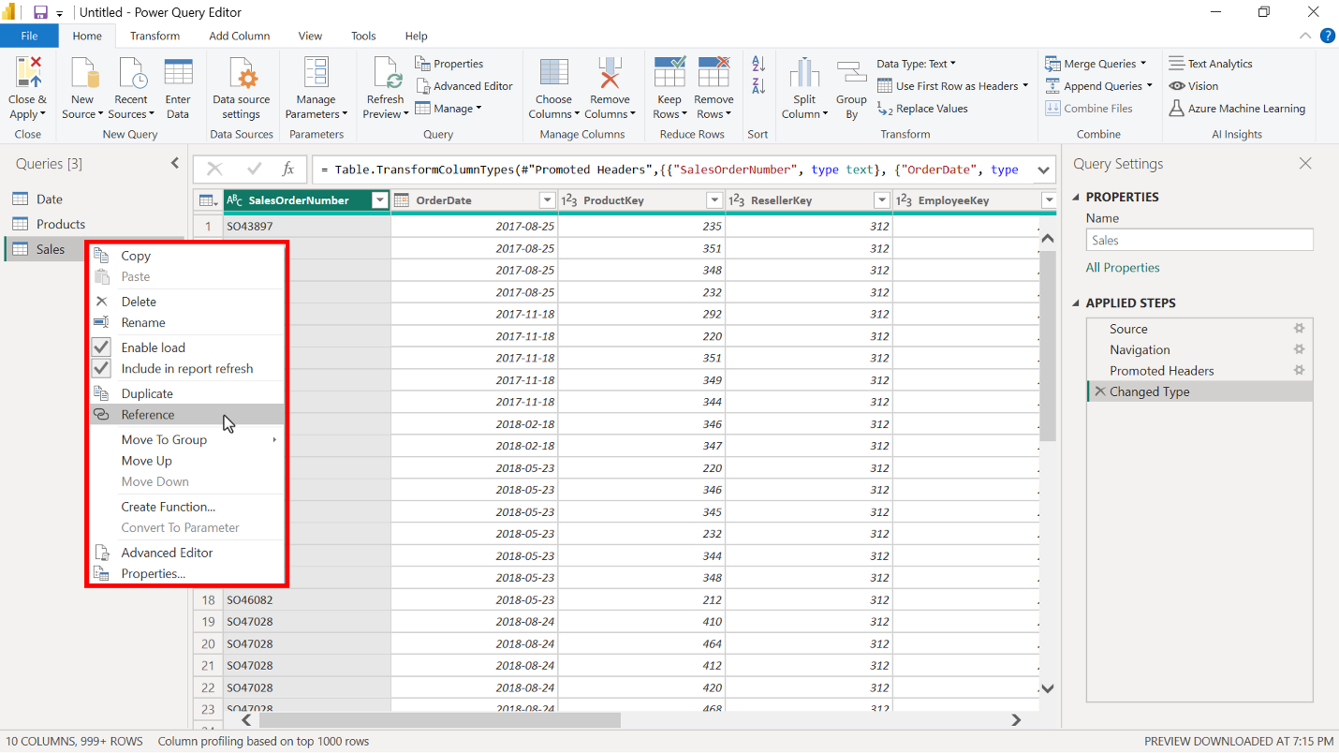

1. In the **Rename** field, rename the new table to **SalesAgg.** Duplications save the original tables for other analytics needs. So always copy the source table and create an aggregate from the duplicate copy.

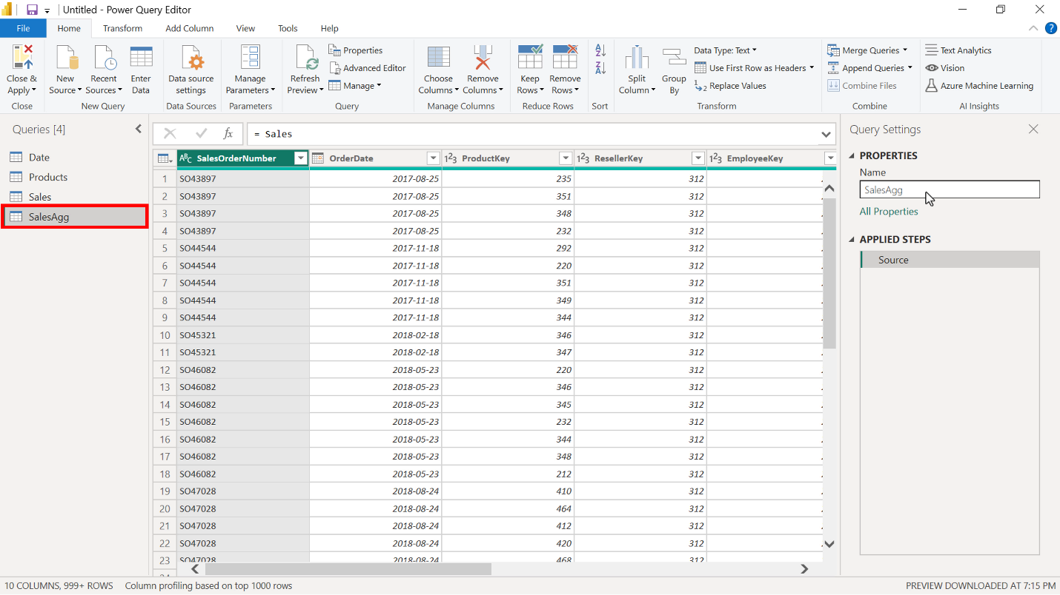

1. Choose the columns that you want to keep in the aggregated table from the source table by selecting the **Choose column** option on the **Home** tab in the **Power Query** editor window.

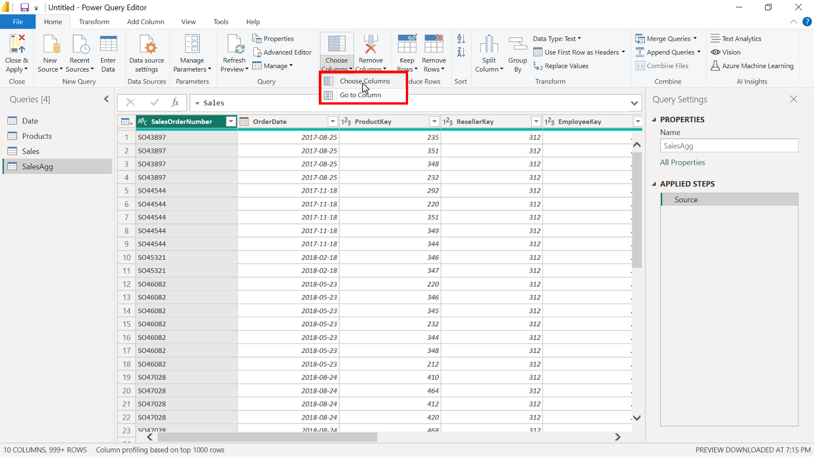

1. In the **Choose column** window select the following columns:

* **OrderDate** (This column is added to group data and will be used for the group by step)
* **Total Sales**
* **Quantity**
* **Cost**

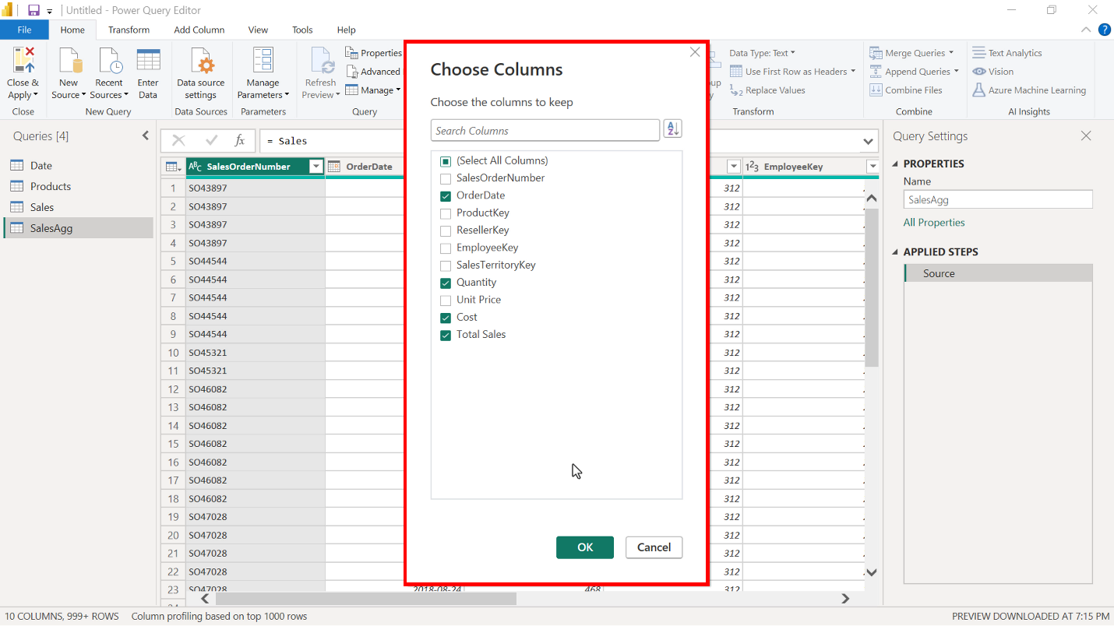

1. Next, select the **Transform** tab in the **Power Query** editor window and then **Group by**. This opens the **Group by** window, where you can define aggregate columns and mathematical operations to compute the aggregation.

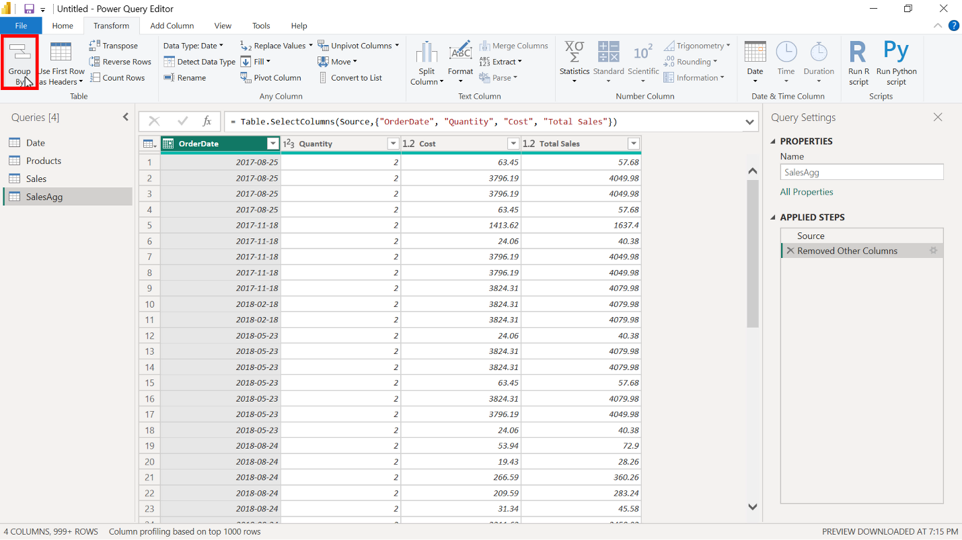

1. Group the aggregation by the **OrderDate** field in the **Group by** window.

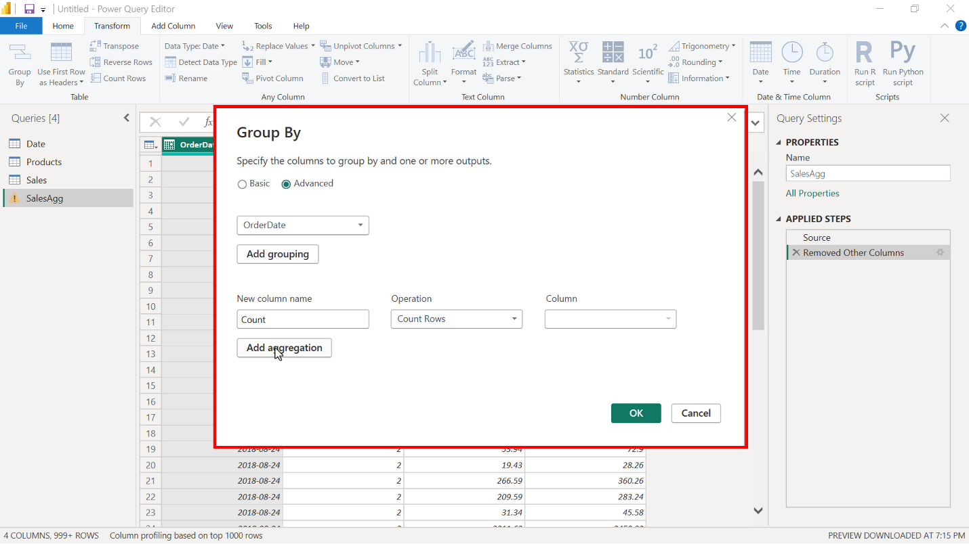

1. Create the following aggregate columns in the **Group by** window:

* **TotalQuantityCount** that uses the **Count** function as an operation.
* **SumTotalSales**, which performs a **Sum** as a mathematical operation and uses **Total Sales** as the column reference.
* **SumCost** also uses the **Sum** function and **Cost** as the column reference.

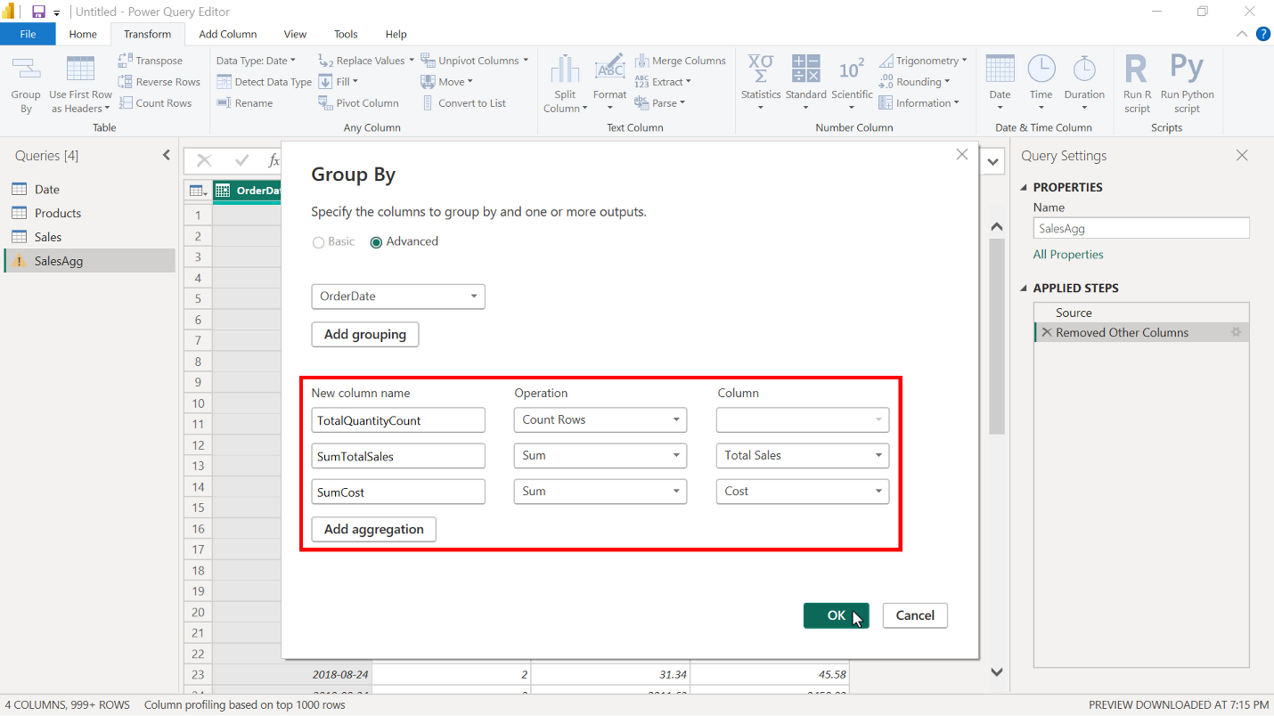

1. Select **OK** to apply all changes to the aggregation.

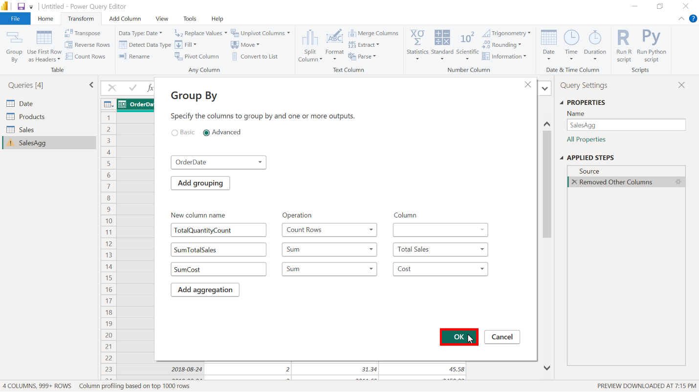

1. Select **Close and apply** on the **Home** tab to close the **Power Query** editor and return to the Microsoft Power BI desktop interface.

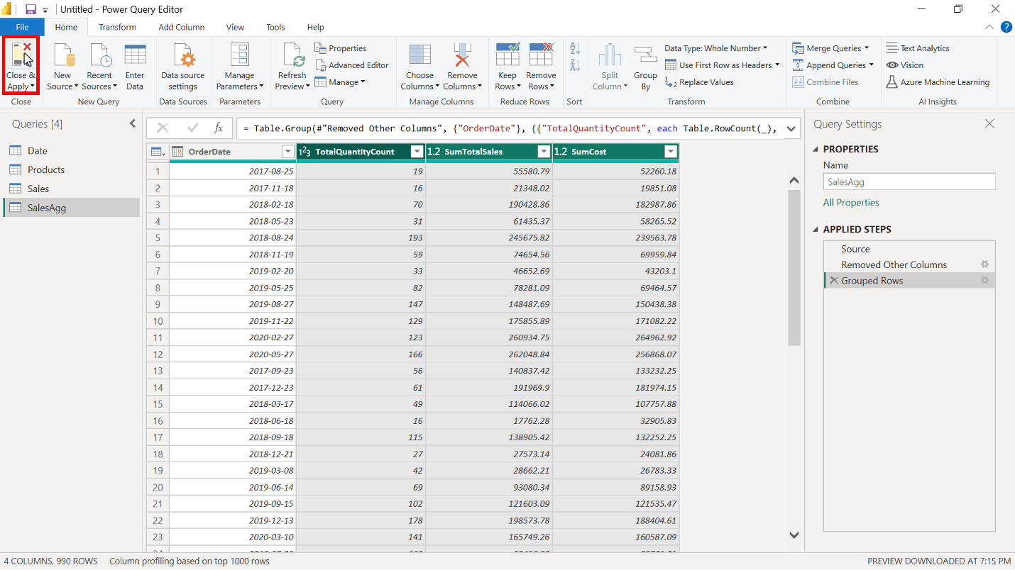

1. Select the table from the **Data** pane to display the total number of rows. In the **Sales** table, the number of rows is **57851**. The number of rows in the **SalesAgg** aggregated table is only **990**, which is 1.71% of the original rows, a significant reduction in data size.

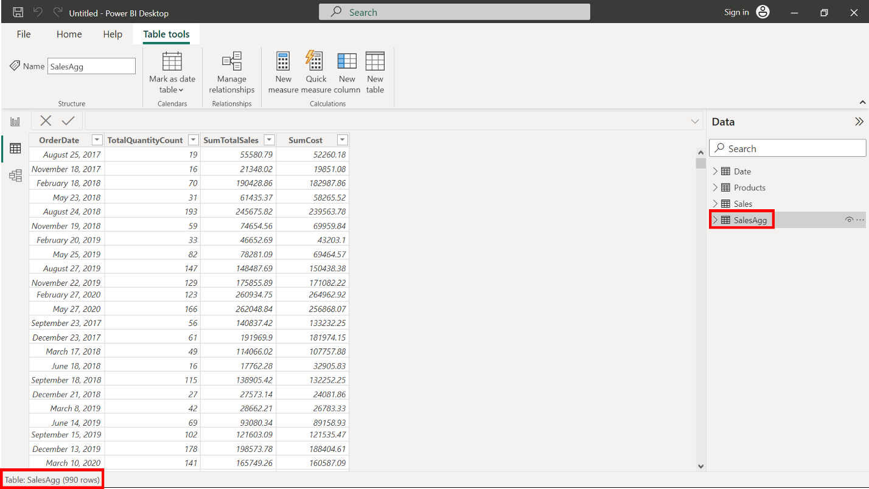

**Step 3: Establish relationship and manage aggregation in Power BI.**

1. The new aggregated **SalesAgg** Fact table does not have a relationship with the **Date** table. Switch to **Model view** and establish a relationship between the two tables based on the **OrderDate** field.

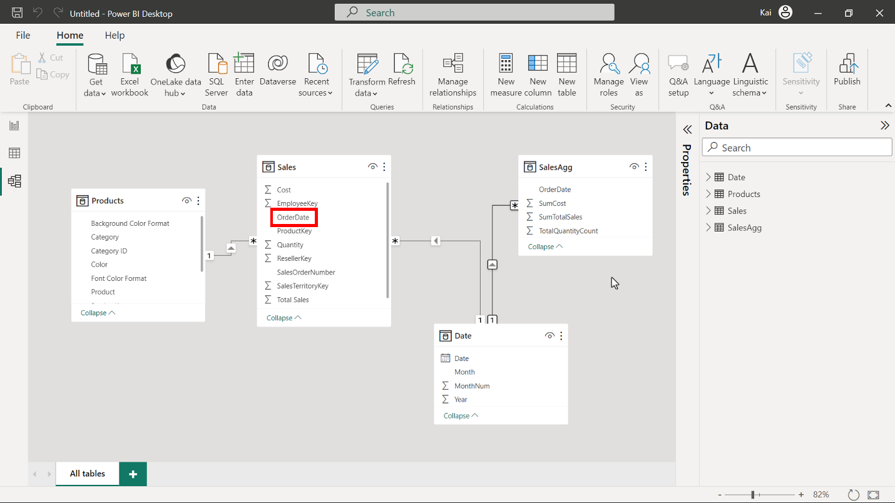

1. Open the **Power Query** editor again to ensure that the data types of the aggregate columns match the data types of the source columns as follows using the Data type icon to the left of each column:

* The data type of the column using **Count must** be set to **Whole number**.
* The data type of **SumTotalSales** and **SumCost** must be **Fixed decimal number**.

You can change the data type by selecting the **Data type** icon on the left side of the column name in the Power Query editor. Once you have completed the data type configuration, select **Close and apply** to return to Power BI desktop interface.

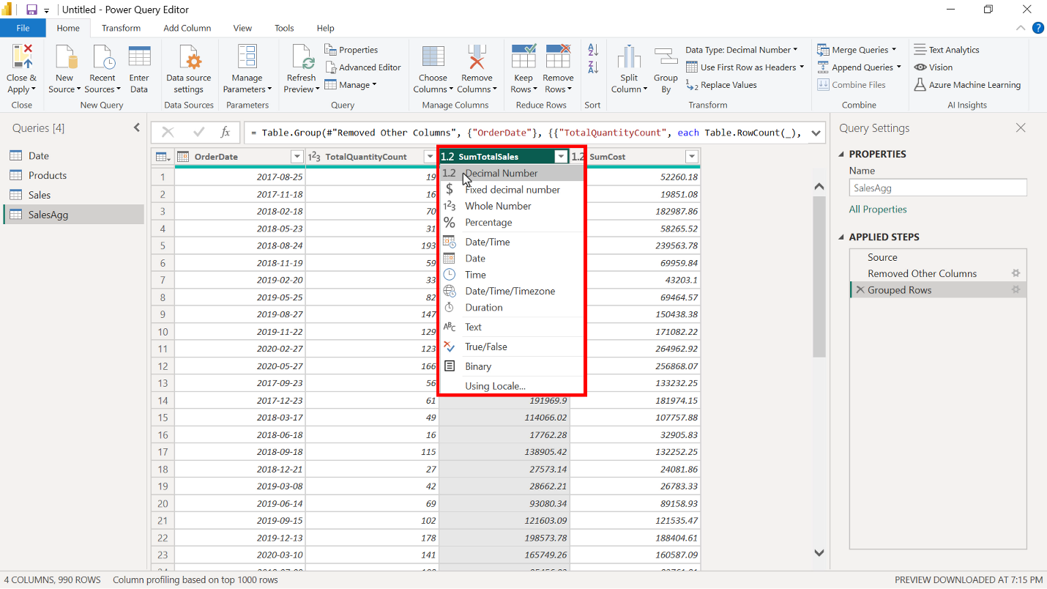

**Step 4: Save the Power BI project.**

* Save the Power BI project to your local computer.

To save the project, open the **File** menu, select **Save As,** and provide an appropriate name for the project along with a path to the folder on your computer.

**How to manage aggregations step-by-step**

**Introduction**

In real-world data analytics, optimizing performance is of key importance, especially when dealing with large datasets. In the context of Power BI, aggregations are pre-calculated summaries of data that allow for quicker query execution and faster rendering of reports. When dealing with millions of rows of datasets, generating reports and dashboards in real-time can be resource-intensive and time-consuming. Aggregations solve this challenge by pre-computing common calculations and sorting them for quick retrieval, thereby significantly improving query performance.

In this reading, you will learn how to manage aggregations within a data model.

In this step-by-step tutorial:

* You'll walk through the steps to manage aggregations in a data model using Power BI.
* The goal is to understand how Power BI facilitates aggregation management.

**Note:** This reading provides an example of the steps you would follow to manage aggregations within a data model.

**Case study**

Adventure Works needs to use a data model with many different data types. However, Power BI is unaware of any aggregation. To address this, it is imperative to let Power BI know about the presence of aggregation. That is why it is necessary to configure and manage aggregations. Let’s walk through Power BI to configure and manage the aggregation we have created previously to use this in our reporting and visualization.

**Step 1: Match the data type of aggregate columns to source columns**

Before managing the aggregation in Power BI, but after configuring the storage mode, you’ll need to go back to the query editor and change the data type of aggregated columns.

1. Navigate to the query editor and select the **Agg_Sales** table from the **Queries** pane on the left side of the query editor.

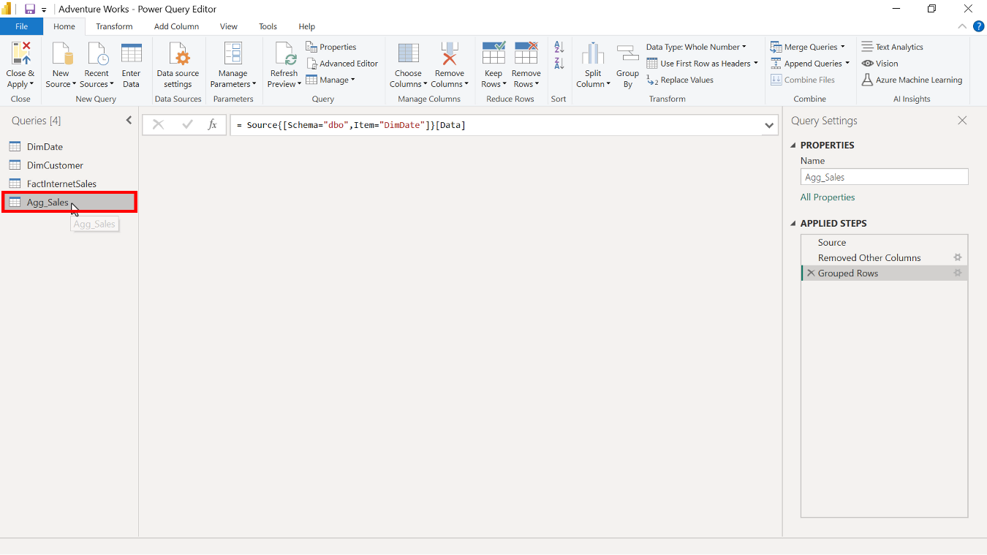

1. Select the **OrderCount** column and ensure the data types are set to **Whole number**. Any column that uses the **Count** function as an operation must have a **Whole number** data type.

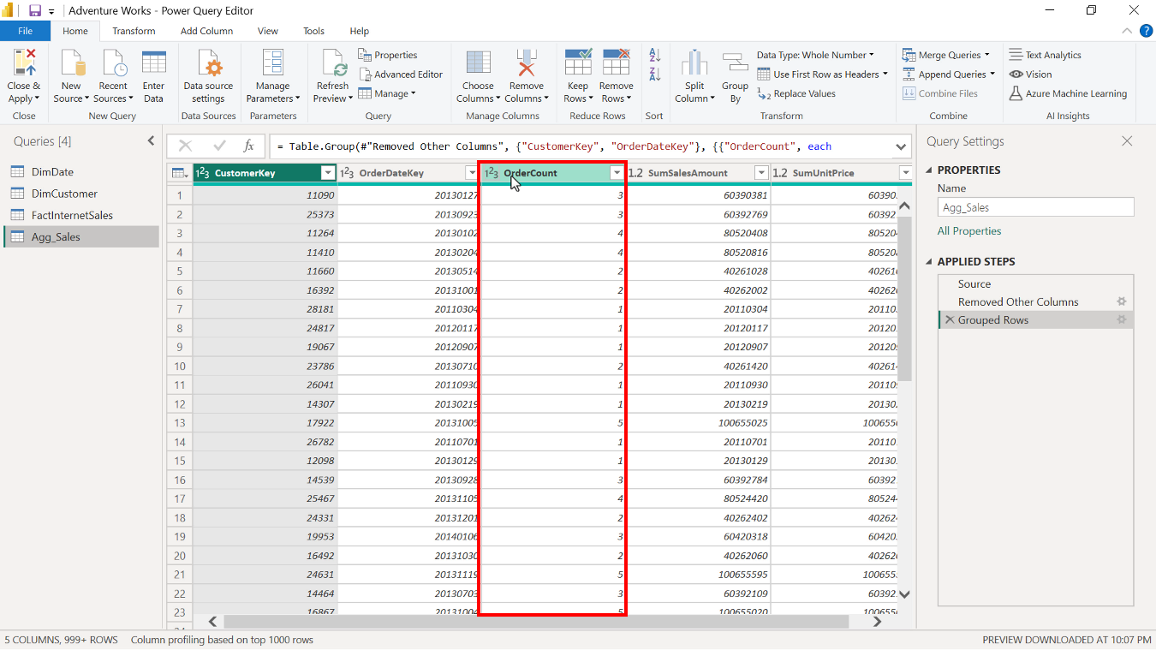

1. Select the **SumSalesAmount** and **SumUnitPrice** columns and change the data type to a fixed decimal number, because the data type of the **Source** column is fixed decimal, and you need to match the data type.

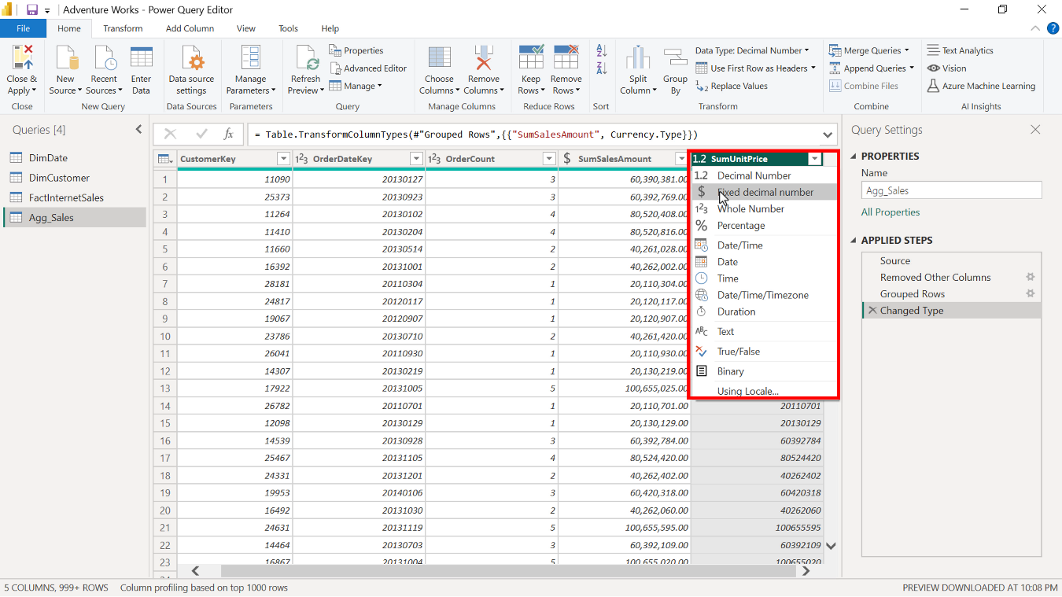

Once completed, check that the data is fixed decimal numbers. Then, close the query editor and return to the Power BI desktop interface.

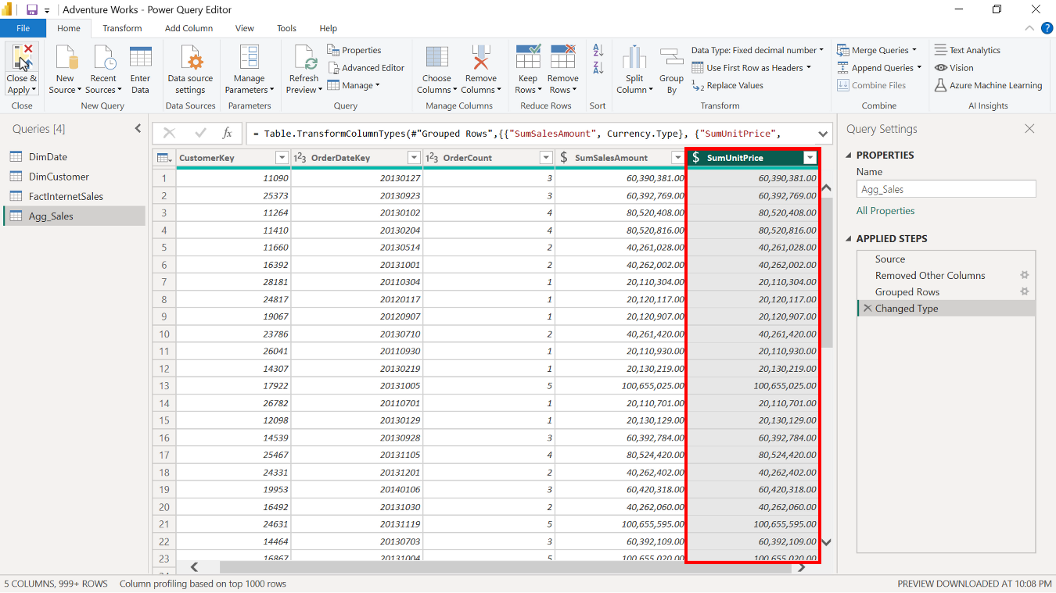

**Step 2: Manage aggregations**

Now, you are ready to manage aggregations.

1. To navigate to the **Manage aggregation** window, select and right-click on the **Agg_Sales** table from the data pane in the **Model view** of Power BI desktop. Select **Manage aggregations** from the drop-down menu.

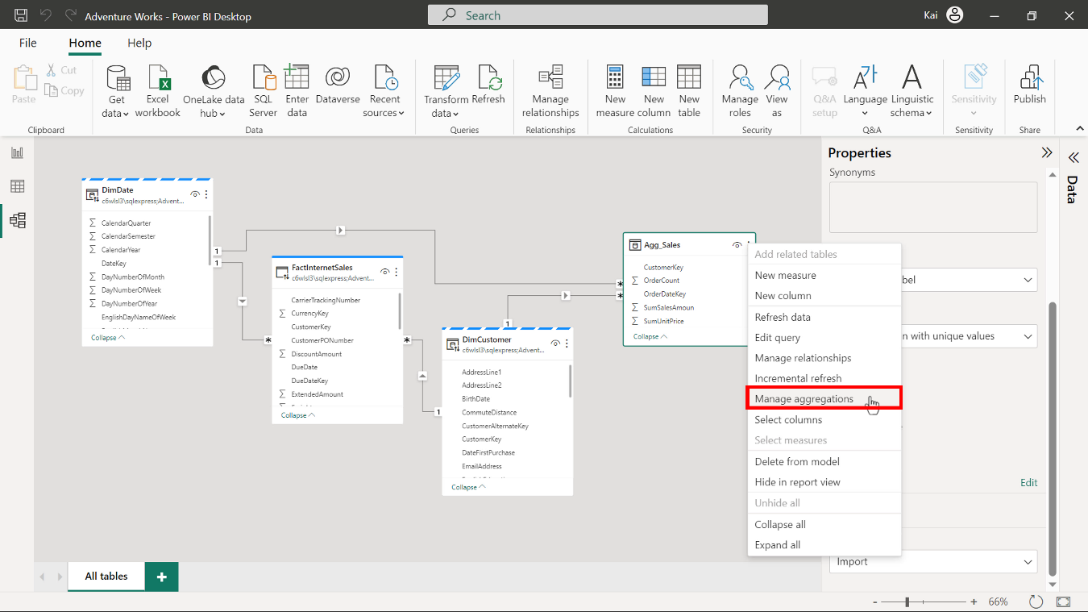

1. The **Manage aggregations** dialog box opens. The aggregation window has four sections:

* **Aggregation columns**
* **Summarization**
* **Detail table**
* And **Detail column**

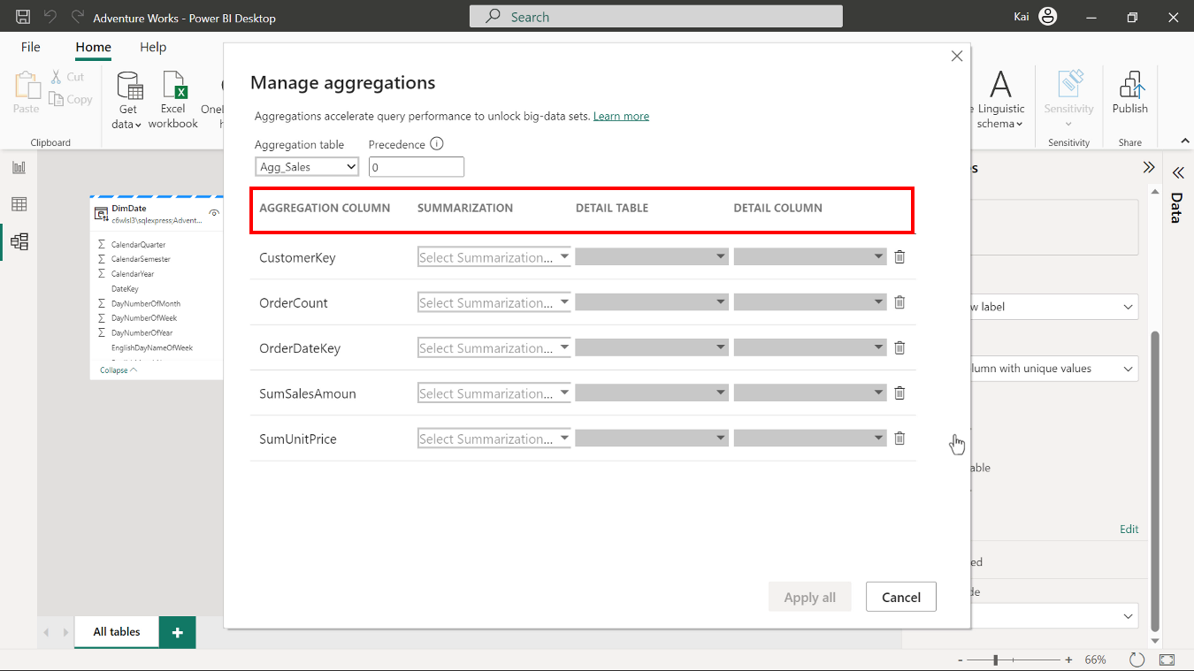

1. Check that the aggregation configuration matches the aggregated table you created during the **Group by** step in Power query editor. In the **Aggregation columns** section, the column names should be as follows:

* **CustomerKey,**
* **OrderDateKey,**
* **OrderCount,**
* **SumSalesAmount**,
* and **SumUnitPrice.**

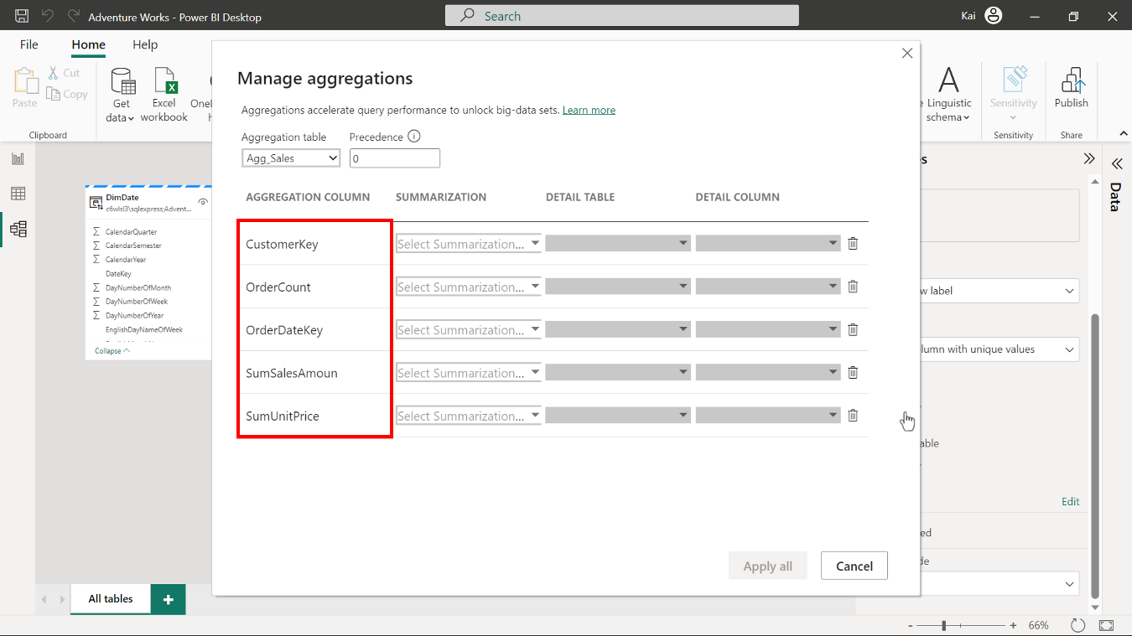

1. In the **Summarization** section, mark the **OrderDateKey** and **CustomerKey** fields as **Group by**, since they’re used to group data.

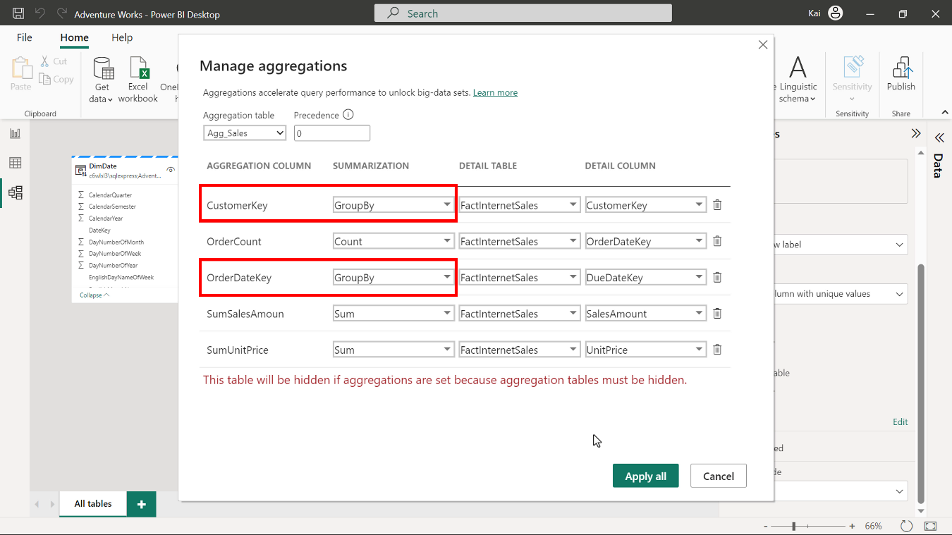

1. **SumSalesAmount** and **SumUnitPrice** are defined to aggregate values from the source table's **Total sales** and **Unit price** columns. Select **Sum** function from the drop-down list, to sum up the values.

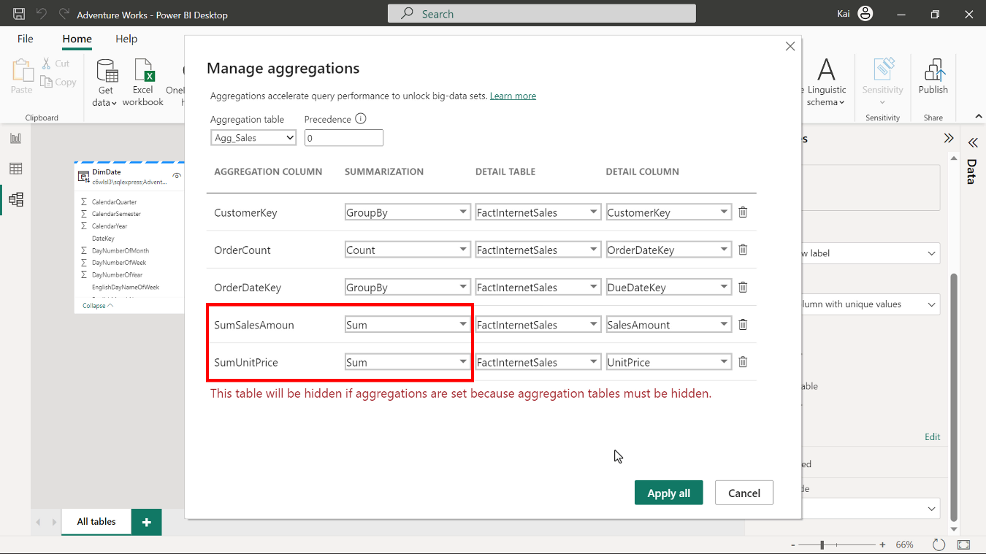

1. Select the **Count** function for the **OrderCount** column from the drop-down list of options to define this column so that it counts the total number of orders.

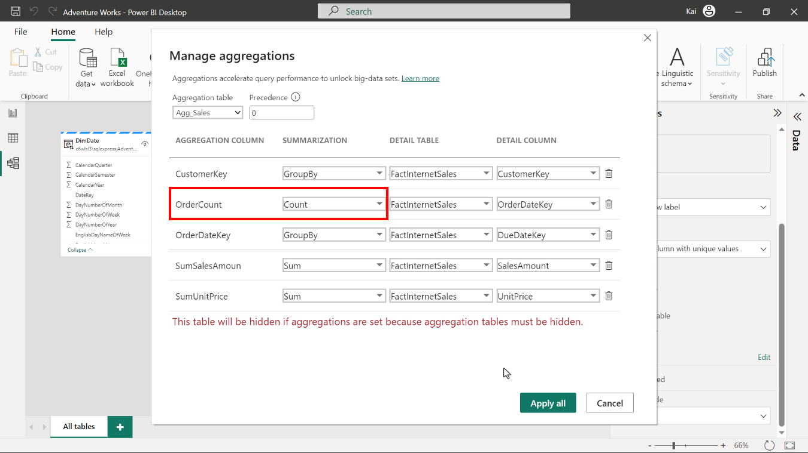

1. In the **Detail table** section, select the **FactInternetSales** table for all columns.

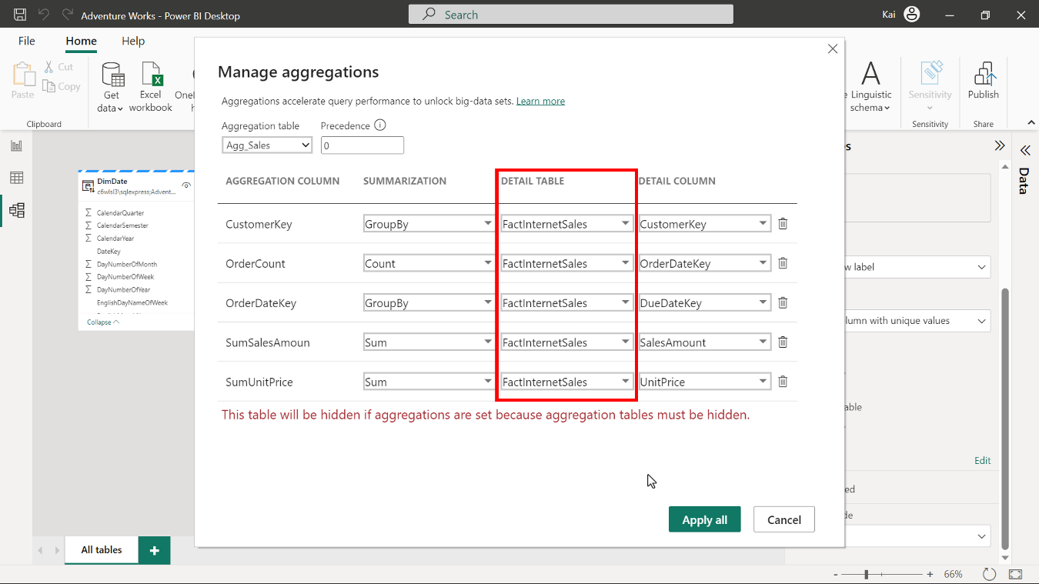

1. Finally, in the **Detail columns** section of the **Manage aggregation** window, map the corresponding column from the **Detail column** drop-down list to the aggregation columns as follows:

* **OrderDateKey** to **OrderDateKey**
* **CustomerKey** to **CustomerKey**
* **OrderCount** to **OrderDateKey**
* **SumSalesAmount** to **SalesAmount**
* **SumUnitPrice** to **UnitPrice**

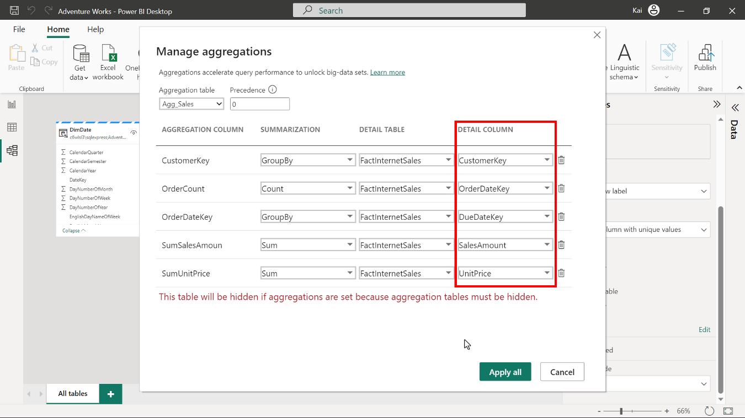

1. Select **Apply all**. The aggregation tables are automatically hidden from the **Report view** in Power BI because users cannot query aggregation tables (this is to avoid security concerns.)

